Herman E. Sautbine
May 11, 1908 – April 23, 2003

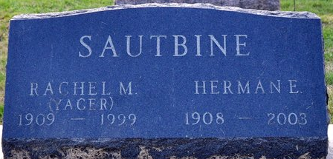
Photo by Deb Curry

Herman E. Sautbine, 94, died Wednesday, April 23, 2003, at Swiss Village, Berne. He was the former owner of Oakwood Mobile Home Park, Portland, and a builder.
Surviving are three sons, William A. Sautbine of Seattle, Wash., Lester H. Sautbine of Portland, Ernie Y. Sautbine of Fishers; one daughter, Mrs. Russell (Dorcas) Plumley of Monroeville; 13 grandchildren; 20 great-grandchildren; and two great-greatgrandchildren.
Service is 1:30 p.m. Saturday at Yager-Kirchhofer Funeral Home, Berne, with calling one hour prior to service. Calling also from 10 to 11 a.m. today at Swiss Village and from 3 to 8 p.m. at the funeral home. Burial in Decatur Cemetery.
Memorials to Swiss Village or Northeast Indiana Hospice.

News-Sentinel, Allen County, Indiana
Friday, April 25, 2003

**
Indiana, U.S., Death Certificates, 1899-2017
Name Herman E Sautbine
Gender Male
Race White
Age 94
Marital Status Widowed
Birth Date 11 May 1908
Birth Place Kirkland Twp Adams Colorado
Death Date 23 Apr 2003
Death Place Berne, Adams, Indiana, USA
Death Registration Date 2003
Father: William O Sautbine
Mother: Carrie B Ward
Informant: Lester H. Sautbine; son; Portland, Indiana
Burial: April 26, 2003; Decatur Cemetery; Decatur, Indiana

