Donna R. (Gilpin) Sautbine
1928 -

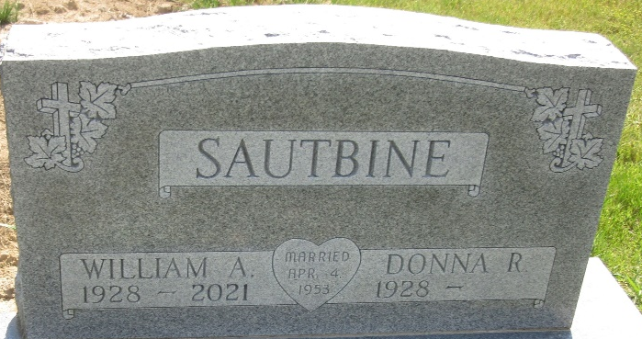
Photo by PLS

