Carrie B. (Ward) Sautbine
January 4, 1876 – August 11, 1967

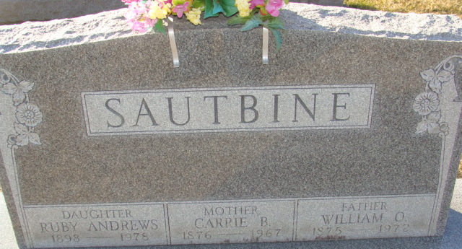
Photo by Alicia Kneuss

Carie B Sautbine
in the Indiana, U.S., Death Certificates, 1899-2017
Name Carie B Sautbine
[Carie B Ward]
Gender Female
Race Caucasian (White)
Age 91
Marital Status Married
Birth Date 4 Jan 1876
Birth Place Indiana
Death Date 11 Aug 1967
Death Place Berne, Adams, Indiana, USA
Death Registration Date 1967
Father: Henry Ward
Mother: Unknown
Informant: William O Sautbine; husband; Decatur, Indiana
Burial: August 14, 1967; Decatur Cemetery; Decatur, Indiana

