Paul M. Saurer
July 27, 1891 – May 27, 1981

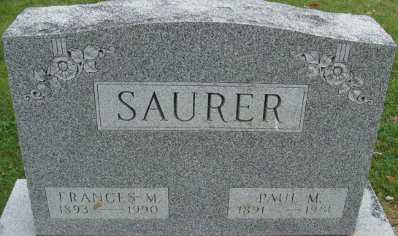
Photo by Alicia Kneuss

Paul M. Saurer
in the Indiana, U.S., Death Certificates, 1899-2017
Name Paul M. Saurer
Gender Male
Race White
Age 89
Marital Status Married
Birth Date 27 Jul 1891
Birth Place Indiana
Death Date 27 May 1981
Death Place Decatur, Adams, Indiana, USA
Death Registration Date 1981
Father: Edward Saurer
Mother: Lucinda Mast
Spouse: Frances Cole
Informant: Mrs. Paul Saurer; wife; Decatur, Indiana
Burial: May 30, 1981; Decatur Cemetery; Decatur, Indiana

