Frances M. (Cole) Saurer
June 5, 1893 – December 7, 1990

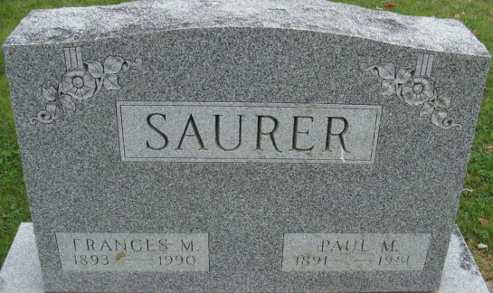
Photo by Alicia Kneuss

Frances C Saurer
in the Indiana, U.S., Death Certificates, 1899-2017
Name Frances C Saurer
[Frances C Cole]
Gender Female
Race White
Age 97
Marital Status Widowed
Birth Date 5 Jun 1893
Birth Place Hopkins, Michigan
Death Date 7 Dec 1990
Death Place Ossian, Wells, Indiana, USA
Death Registration Date 1990
Father: Jess Cole
Mother: Lulu Carrel
Spouse: Paul M Saurer
Informant: Dave Cole; nephew; Fort Wayne, Indiana
Burial: December 9, 1990; Decatur Cemetery; Decatur, Indiana

