Wilma Leola Sauer
September 4, 1919 – March 18, 1971

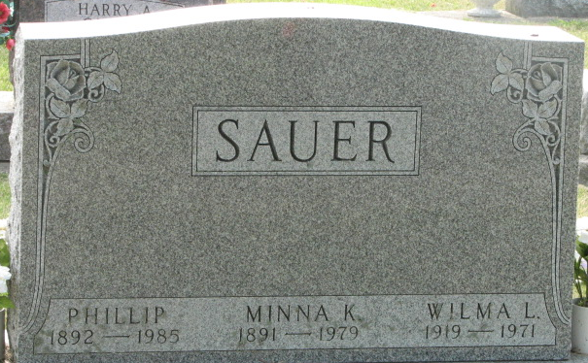
Photo by Alicia Kneuss

Wilma Leola Sauer is Taken by Death
Miss Wilma Leola Sauer, 51, of 1103 Marshall St., died at 1:40 a.m. this morning at home following an illness of two years. Miss Sauer resided with her parents, Mr. and Mrs. Philip Sauer, and was never married.
Miss Sauer was a member of the Decatur Zion Lutheran church.
Born in Union Township, September 4, 1919, she was a daughter of Philip and Minna Weinman-Sauer.
Surviving are her parents, three sisters, Mrs. Florence Engle, Decatur; Mrs. Paul (Vera) Hammond, route 4; Mrs C. William (Clarice) Porter, Decatur; two brothers, Ralph Sauer, Decatur and Harold Sauer, route 1.
Funeral services will be conducted at 2 p.m. Wednesday at the Zwick Funeral Home, with Rev. Paul Ludwig officiating. Burial will be in the Decatur Cemetery. Friends may call at the Zwick Funeral Home after 7 p.m. today.
Preferred memorials are to the Bethesda Lutheran Home or the American Cancer Society.

Decatur Daily Democrat, Adams County, Indiana
March 18, 1971

