Reinhold F. Sauer
August 3, 1911 – December 1, 1993

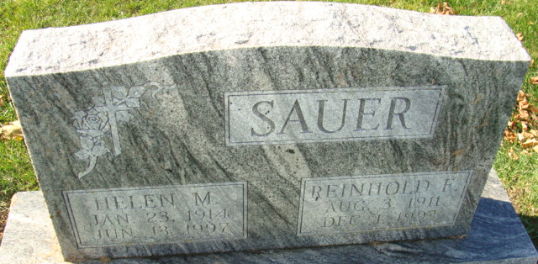
Photo by Alicia Kneuss

Reinhold F Sauer
in the Indiana, U.S., Death Certificates, 1899-2017
Name Reinhold F Sauer
Gender Male
Race White
Age 82
Marital Status Married
Birth Date 3 Aug 1911
Birth Place Van Wert County, Ohio
Death Date 1 Dec 1993
Death Place Decatur, Adams, Indiana, USA
Death Registration Date 1993
Father: Henry Sauer
Mother: Justine Pflueger
Spouse: Helen M Fritzinger
Informant: Helen M. Sauer; wife; Decatur, Indiana
Burial: December 4, 1993; Decatur Cemetery; Decatur, Indiana

