Phillip Sauder
February 13, 1892 – August 21, 1985

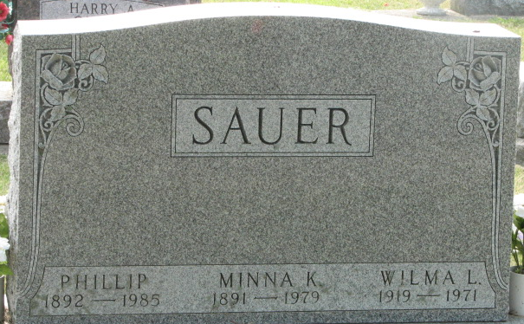
Photo by Alicia Kneuss

Philip (Phil) Sauer, 93, 1103 Marshall St., prominent Decatur resident and a former Decatur County Commissioner, Decatur Street commissioner, and county highway department supervisor, died at 12:48 p.m. Wednesday at the Decatur Community Care Center, following an illness of two months. He had resided at the Care Center for six weeks.
Active in civic affairs for many years, Mr. Sauer was elected commissioner in 1932 and served six years. During WWII, he accepted a five-year appointment (1943-47) as Decatur Street commissioner and served as county highway supervisor from 1948-50. He was also an active member of Decatur Zion Lutheran Church. He was a former financial secretary and trustee and was on the building committee for the 1936 church remodeling and on the same committee for the present sanctuary and school addition in the 1960s.
He was one of the founders of the 39ers senior citizen organization (now called Adams County Senior Citizens) and its first president.
Born in Heinstadt, Odenwald, Germany on February 13, 1892, he was the ninth child (of ten) of John and Anna Meisinger-Sauer. The Sauer family came to the United States in 1895 settling near the village of Schumm, Ohio in Van Wert County.
As a young man, Phil was left with the responsibility of taking care of the family farm. In between planting seasons, he worked in the oil fields in the community in the 1900s, earning $5 to $6 per day. At the age of 21, he hired out to a farmer for $28 a month, plus room and board. On April 19, 1914, he married Minna K Weinman, she died May 23, 1979. They were married 65 years.
In 1915, the Sauers rented 180 acres of Union Township, where he farmed for six years. He then purchased 20 acres in 1921. The same year, he turned to construction and built the Riverside Garage on Monroe St. Later he built homes in Decatur, Fort Wayne, and Hartford City. He also built many patios throughout Decatur before retiring in 1977.
He moved with his family from the farm to Decatur on 1104 Nuttman Ave, in 1936, and later moved to 1103 Marshall St.
Survivors include five children, Florence A Engle, Decatur; Harold Sauer, route 1, Decatur; Vera Hammond, Decatur; Mrs. C William (Clarice) Porter, Decatur; and Ralph Sauer, Decatur; 18 grandchildren; and 25 great-grandchildren. One daughter, Wilma and two grandchildren preceded him in death.
Services will be conducted Saturday at 11 a.m. at Decatur Zion Lutheran Church, Rev. Donald W. Biester officiating. Burial will be in the Decatur Cemetery. Friends may call at Zwick, Boltz & Jahn Funeral Home from 7-9 p.m. today and from 2-9 pm Friday, and after 10 a.m. Saturday at the church.
Memorials are to the Zion Lutheran Church Memorial Fund.

Decatur Daily Democrat, Adams County, Indiana
Unknown date
**
Indiana, U.S., Death Certificates, 1899-2017
Name Philip Sauer
Gender Male
Race White
Age 93
Marital Status Widowed
Birth Date 13 Feb 1892
Birth Place Germany
Death Date 21 Aug 1985
Death Place Decatur, Adams, Indiana, USA
Death Registration Date 1985
Father: John Sauer
Mother: Anna Meisinger
Informant: Ralph Sauer; son; Decatur, Indiana
Burial: August 24, 1985; Decatur Cemetery; Decatur, Indiana

