Minna Katherine (Weinman) Sauer
May 29, 1891 – May 23, 1979

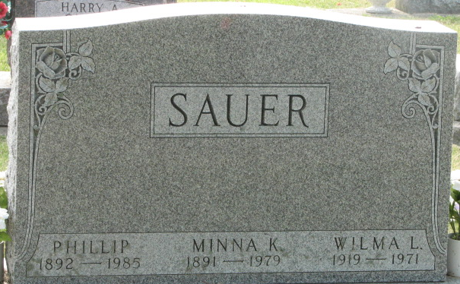
Photo by Alicia Kneuss

Mrs. Minna K. Sauer, 87, of 1103 Marshall St., the wife of Philip Sauer, died at 8:35 p.m. Wednesday at the Meadowvale Care Center, Bluffton, where she had resided for the past three weeks. She had been a patient at the Adams County Memorial Hospital for three weeks prior to that time.
She was a member of the Zion Lutheran Church, Decatur; the Missionary Society, the Needle Club and the Alter Guild of the church, and the Senior Citizens organization of Decatur.
Born in Schumm, Ohio, on May 29, 1891, she was the daughter of John George and Mary Gunsett-Weinman, and was united in marriage on April 19, 1914 to Philip Sauer, who survives. Mr. and Mrs. Sauer celebrated their 65th wedding anniversary this year.
Also surviving are five children, Harold Sauer, route 1, Decatur; Ralph Sauer, Decatur; Mrs. Florence A. Engle, Decatur; Mrs. Paul (Vera) Hammond, route 4, Decatur; Mrs. C. William (Clarice) Porter, Decatur; 18 grandchildren; and 13 great-grandchildren. One daughter, Wilma, four brothers, one sister, and two grandchildren preceded her in death.
Funeral services will be conducted at 11 a.m. Saturday at the Decatur Zion Lutheran Church with Rev. Donald W. Biester officiating. Burial will be in the Decatur Cemetery. Friends may call at the Zwick Funeral Home after 7 p.m. today and until 9 a.m. Saturday and at the church from 10 a.m. until time of the services at 11.

Decatur Daily Democrat, Adams County, Indiana
Unknown date
**
Indiana, U.S., Death Certificates, 1899-2017
Name Minna Katherine Sauer
[Minna Katherine Weinman]
Gender Female
Race White
Age 87
Marital Status Married
Birth Date 29 May 1891
Birth Place Ohio
Death Date 23 May 1979
Death Place Bluffton, Wells, Indiana, USA
Death Registration Date 1979
Father: John George Weinman
Mother: Mary Gunsett
Spouse: Phillip Sauer
Informant: Phillip Sauer; Decatur, Indiana
Burial: May 26, 1979; Decatur Cemetery; Decatur, Indiana

