Helen M. (Fritzinger) Sauer
January 23, 1914 – June 13, 1997

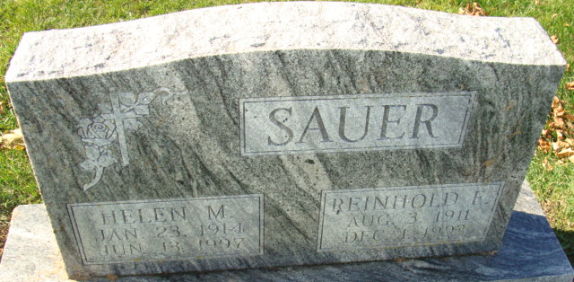
Photos by Alicia Kneuss

Helen M. Sauer
in the Indiana, U.S., Death Certificates, 1899-2017
Name Helen M. Sauer
[Helen M. Fritzinger]
Gender Female
Race White
Age 83
Marital Status Widowed
Birth Date 23 Jan 1914
Birth Place Adams County, Indiana
Death Date 13 Jun 1997
Death Place Decatur, Adams, Indiana, USA
Death Registration Date 1997
Father: Curt Fritzinger
Mother: Vera Hammond
Informant: Barbara Melchi; daughter; Decatur, Indiana
Burial: June 17, 1997; Decatur Cemetery; Decatur, Indiana

