Infant daughter Sapp
April 22, 1961 – April 22, 1961

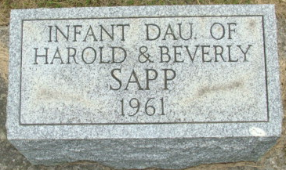
Photo by Alicia Kneuss

Rites Held Today For Sapp Infant

Graveside services were held this morning at the Decatur Cemetery for the infant daughter of Harold and Beverly Hakes Sapp of 1128 West Elm Street. The infant died at 9:30 p.m. Saturday at the Adams County Memorial Hospital, where she was born at 2:16 p.m.
Services were conducted by the Rev. J. O. Penrod officiating.
Surviving in addition to the parents are a brother, Terry, and a sister, Cheryl, both at home; and the grandparents, Mr. and Mrs. Harrison D. Hakes and Mr. and Mrs. Lewis Sapp of Decatur, and Mr. and Mrs. Jess Rupert of St. Mary's, Ohio.

Decatur Daily Democrat, Adams Co, Indiana
Monday, April 24, 1961

