Harold Martin Sapp
January 23, 1926 – August 19, 2001

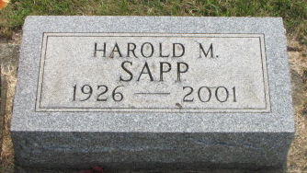
Photo by Alicia Kneuss

Harold M. Sapp, 75, 227 S. Fifth St., died at home at 1:50 p.m. Sunday. He had lived in Decatur since 1936. He was born on January 23, 1926 in Mercer County, Ohio to Lewis and Orpha F. Miller Sapp and married Beverly J. Hakes on September 30, 1974.
He was a custodian for many years for the North Adams Schools before retiring. Mr. Sapp was most popularly known as "The Chief" or as "Chief Harold" because of decades of dressing up in a Native American chief's regalia and attending an uncountable number of Bellmont High School sporting events as the official BHS mascot. He attended First Baptist Church in Decatur and was a member of American Legion Post 43 in Decatur.
During World War II, he served in the U.S. Army and was stationed in Japan after the war.
Surviving are a daughter, Cheryl L. Sapp of Decatur; a son, a brother, Edgar L. Sapp of Auburndale, Florida; three grandchildren; and five great-grandchildren. A daughter died at birth and a brother and great-grandchild are also deceased.
Funeral services will be held at 10:30 a.m. Wednesday in Zwick and Jahn Funeral Home, Decatur, with burial in Decatur Cemetery, including military graveside rites by the color guard from American Legion Post 43. Visiting hours are 2-5 and 6-8 p.m. Tuesday.
Preferred memorials are to Family Hospice of Northeast Indiana, located in Berne.

Decatur Daily Democrat, Adams Co, Indiana
Monday, August 20, 2001

