Cheryl L. Sapp
May 19, 1946 – November 23, 2020

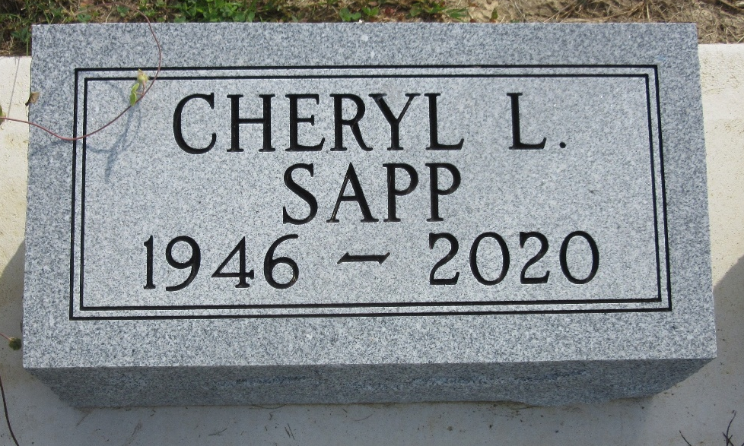
Photo by PLS

Cheryl L. Sapp, 74, of Decatur, Indiana passed away Monday, November 23, 2020, at Lutheran Hospital in Fort Wayne, Indiana.
She was born May 19, 1946 in Decatur, Indiana to the late Harold M. Sapp and the late Beverly J. (Hakes) Sapp. Cheryl graduated from Decatur High School class of 1964 and a member of First Baptist Church in Decatur. She was a homemaker.
Cheryl is survived by two sons, Benjamin Sapp of Decatur, Indiana and Michael Sapp of Clarksville, Tennessee; three grandchildren, Emily Sapp, Cassandra Swift and Justin Sapp; three great-grandchildren, and a brother, Terry Sapp. She was preceded in death by a grandson, Dakota.
Funeral service will be held at 11:00 a.m. Tuesday, December 1, 2020, at Zwick & Jahn Funeral Home in Decatur with Pastor Whitney West officiating. Burial will follow at Decatur Cemetery. Friends and family will be received from 10:00-11:00 a.m. Tuesday, December 1, 2020, at Zwick & Jahn Funeral Homes in Decatur.
Preferred memorials are to First Baptist Church in Decatur.

Zwick & Jahn Funeral Home, Adams County, Indiana
November 24, 2020

