Beverly Joan (Hakes) Sapp
August 6, 1926 – August 9, 1974

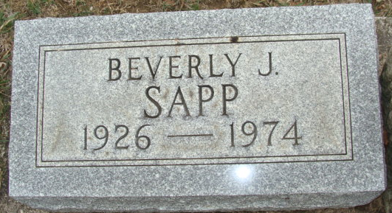
Photo by Alicia Kneuss

Beverly J. Sapp Dies at Age 48

Mrs. Beverly J. Sapp, 48, of 227 South Fifth St., wife of Harold M. Sapp, died at 3:45 p.m. Friday at Parkview Memorial Hospital, Fort Wayne. She had been in critical condition for the past nine days.
She was born in Decatur on August 6, 1926 to Harrison and Dorothy Schnepp-Hakes, and was married on Sept. 30, 1948, to Harold M. Sapp.
Survivors include her mother of Decatur; the husband, employed by the North Adams Community School System; two children; Mrs. Cheryl Mendoza and Terry Sapp, both of Decatur; two brothers, Harrison Hakes and James Hakes, both of Decatur; three grandchildren, Benjamin and Michael Mendoza and Laura Sapp.
Funeral services will be held Monday at 1:30 p.m. at the Zwick Funeral Home, with Rev. Sylvester Martin officiating. Burial will be in the Decatur Cemetery. Friends may call at the funeral home after 10 a.m. Sunday.

Decatur Daily Democrat, Adams Co, Indiana
Saturday, August 10, 1974

