Jerden F. Sanmann
November 23, 1890 – November 29, 1988

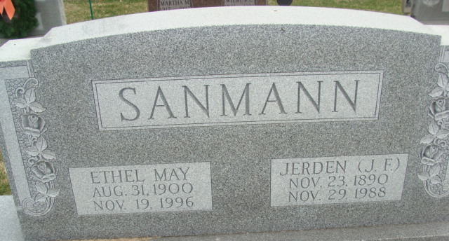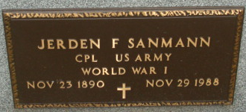
Photo by Alicia Kneuss

Jerden F Sanmann
in the Indiana, U.S., Death Certificates, 1899-2017
Name Jerden F Sanmann
Gender Male
Race White
Age 98
Marital Status Married
Birth Date 23 Nov 1890
Birth Place Glasford, Illinois
Death Date 29 Nov 1988
Death Place Decatur, Adams, Indiana, USA
Death Registration Date 1988
Father: William Sanmann
Mother: Renee Lohr
Spouse: Ethel May
Informant: Ethel May Sanmann; wife; Decatur, Indiana
Burial: December 1, 1988; Decatur Cemetery; Decatur, Indiana

