Ethel May (Woods) Sanmann
August 31, 1900 – November 19, 1996

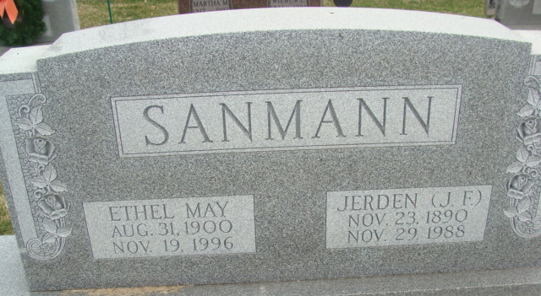
Photo by Alicia Kneuss

Ethel May Sanmann, 96, of Decatur died Tuesday in Woodcrest Retirement Center. The Diller, Neb., native retired in 1978 as a real estate broker after 39 years and was the widow of Jerden F., who died in 1988.
Surviving is a niece, Marjorie L. Howe of Scottsdale, Ariz.
Services are 3:30 p.m. Friday in Zwick, Sefton & Jahn Funeral Home, Decatur, where calling is 3 to 5 and 7 to 9 p.m. today. Burial will be in Decatur Cemetery.
Memorials are to charity.

News-Sentinel, Allen County, Indiana
Thursday, November 21, 1996

