Rebecca Jane (Landreth) Sanders
December 24, 1874 – May 4, 1949

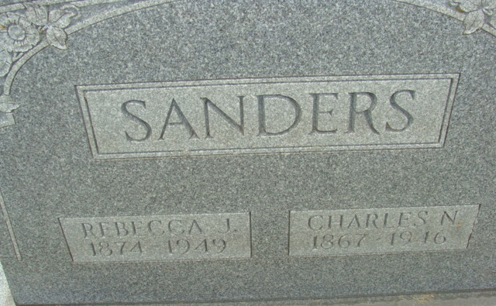
Photo by Alicia Kneuss

Mrs Rebecca Jane Sanders
in the Indiana, U.S., Death Certificates, 1899-2017
Name Mrs Rebecca Jane Sanders
[Mrs Rebecca Jane Landreth]
Gender Female
Race White
Age 74
Marital Status Widowed
Birth Date 24 Dec 1874
Birth Place Indiana
Death Date 4 May 1949
Death Place Decatur, Adams, Indiana, USA
Death Registration Date 1949
Father: William Landreth
Mother: Nancy Pruitt
Informant: Mrs. Ethel Connelly; Decatur, Indiana
Burial: May 6, 1949; Decatur Cemetery; Decatur, Indiana

