Cynthia May (Rupert) Sanders
June 1, 1886 – October 17, 1916

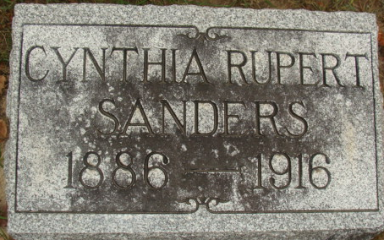
Photo by Alicia Kneuss

Cynthia May Sanders nee Rupert, was born near Spencerville, Allen County, Ohio, June 1, 1886, and died at the Taylors Hospital at Montpelier, Indiana October 17, 1916, aged 30 years, 4 months and 16 days. She was married to Henry Sanders on June 23, 1906.
She professed Christ and joined the M. E. Church at Monroe, Indiana when a young girl.
She leaves to mourn a husband and little eight-year-old Cloa Smith, to whom they had given a home for two years, a mother, four brothers and two sisters. She being the fourth of the family circle to cross the Jordon of death.
She with her husband and relatives had visited relatives in Tipton and Madison Counties, Indiana. She met her death, caused by a false signal given by the flagman at Windsor Street crossing on the Lake Erie & Western Railroad at Montpelier, Indiana, while enroute home in an auto.
Funeral services were held at the M. E. Church on Friday afternoon conducted by the writer, assisted by Rev. Phillips of the M. E. Church. Interment at Decatur.
She was the daughter of the late Rev. L. L. Rupert of the Auglaize Conference.

Unknown source
**

Indiana, U.S., Death Certificates, 1899-2017

Name Cynthia May Sanders [Cynthia May Rupert]
Gender Female
Race White
Age 30
Marital Status Married
Birth Date Jun 1, 1886
Birth Place Ohio
Death Date 17 Oct 1916
Death Place Montpelier, Blackford, Indiana, USA
Father: Lewis L. Rupert
Mother: Anna Trippe
Spouse: Henry Sanders, informant, Monroe, Indiana
Burial: October 19, 1916; Decatur, Indiana

