Charles Newton Sanders
October 8, 1867 – September 26, 1946

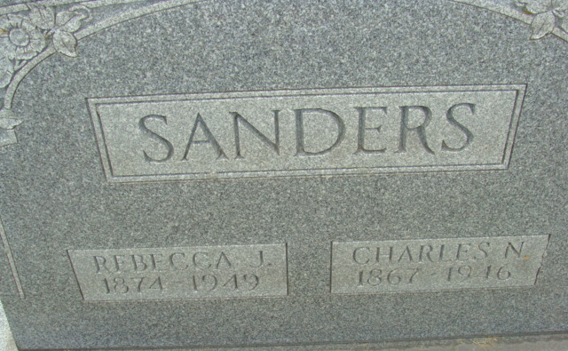
Photo by Alicia Kneuss

Charles Newton Sanders
in the Indiana, U.S., Death Certificates, 1899-2017
Name Charles Newton Sanders
Gender Male
Race White
Age 78
Marital Status Married
Birth Date 8 Oct 1867
Birth Place Lawrence Co Indiana
Death Date 26 Sep 1946
Death Place Decatur, Adams, Indiana, USA
Death Registration Date 1946
Father: Joseph Sanders
Mother: Sarah Riggs
Spouse: Rebecca June Landreth; age 71
Informant: Mrs. C. N. Sanders; Decatur, Indiana
Burial: September 29, 1946; Decatur Cemetery; Decatur, Indiana

