Mary Sampson
May 28, 1906 – September 3, 1906

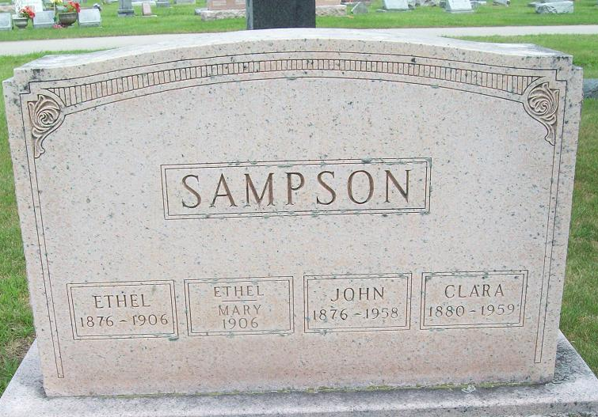
Photo by Alicia Kneuss

Mary Sampson
in the Indiana, Death Certificates, 1899-2011
Name: Mary Sampson
Gender: Female
Race: White
Age: 3 months, 5 days
Birth Date: 28 May 1906
Birth Place: Fort Wayne Ind.
Death Date: 3 Sep 1906
Death Place: Fort Wayne, Allen, Indiana , USA
Father: John Sampson
Mother: Mary E Burkhardt
Informant: John Sampson
Burial: Sept. 5, 1906; Decatur Cem.

