Martha (Close) Sampson
September 19, 1856 – February 2, 1931

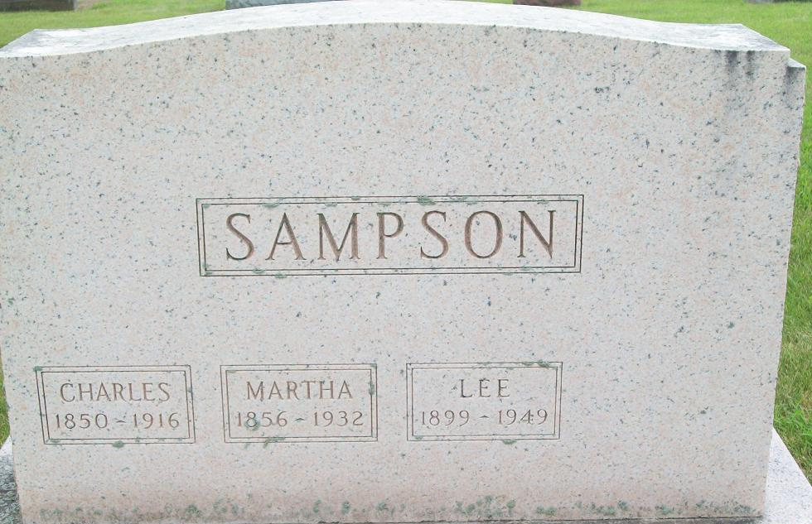
Photo by PLS

Martha Eiter
in the Indiana, U.S., Death Certificates, 1899-2017
Name Martha Eiter
[Martha Close]
Gender Female
Race White
Age 74
Marital Status Widowed
Birth Date 19 Sep 1856
Birth Place Indiana
Death Date 2 Feb 1931
Death Place Fort Wayne, Allen, Indiana, USA
Death Registration Date 1931
Father: John Close
Mother: Whiteher
Spouse: Henry Eiter
Informant: Mrs. Clarence Dickey
Burial: February 4, 1931; Decatur, Indiana

