Lewis Sampson
March 3, 1879 – July 31, 1936

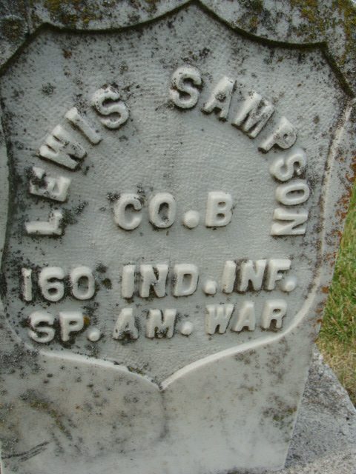
Photo by PLS

Louis Sampson
in the Indiana, U.S., Death Certificates, 1899-2017
Name Louis Sampson
Gender Male
Race White
Age 57
Marital Status Married
Birth Date 3 Mar 1879
Birth Place Indiana
Death Date 31 Jul 1936
Death Place Fort Wayne, Allen, Indiana, USA
Death Registration Date 1936
Father: Charles Sampson
Mother: Unknown
Spouse: Mammie
Informant: Mrs. Louis Sampson
Burial: August 3, 1936; Decatur, Indiana

