Lee Ottis Sampson
June 15, 1899 – October 26, 1949

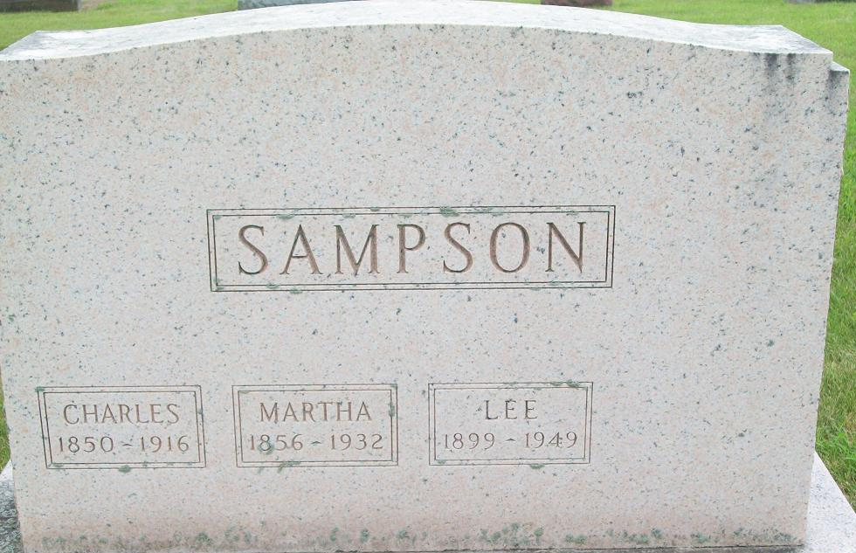
Photo by PLS

Lee Ottis Sampson
in the Indiana, U.S., Death Certificates, 1899-2017
Name Lee Ottis Sampson
Gender Male
Race White
Age 50
Veteran: World War I
Marital Status Married
Birth Date 15 Jun 1899
Birth Place Decatur, Indiana
Death Date 26 Oct 1949
Death Place Fort Wayne, Allen, Indiana, USA
Death Registration Date 1949
Father: John Sampson
Mother: Clara Showalter
Informant: Mrs. Lee O. Sampson; Fort Wayne, Indiana
Burial: October 29, 1949; Maplewood Cemetery; Decatur, Indiana

