John C. Sampson
March 14, 1876 – April 3, 1958

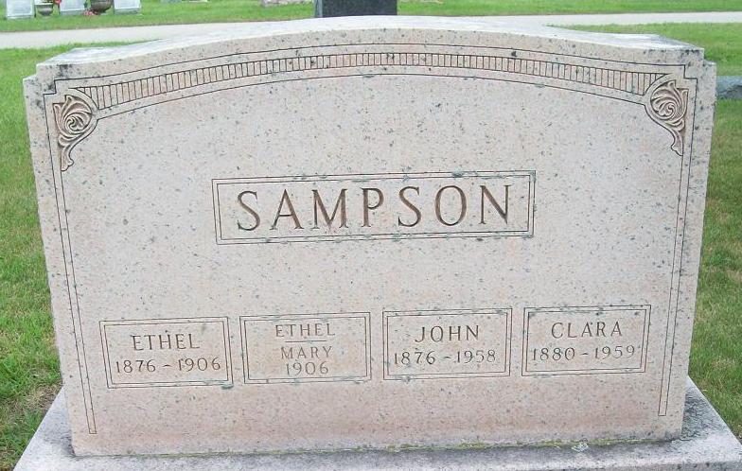
Photo by PLS

John C. Sampson
in the Indiana, U.S., Death Certificates, 1899-2017
Name John C. Sampson
Gender Male
Race White
Age 83
Marital Status Married
Birth Date 14 Mar 1876
Birth Place Indiana
Death Date 3 Apr 1958
Death Place Bluffton, Wells, Indiana, USA
Death Registration Date 1958
Father: Charles T. Sampson
Mother: Martha Close
Informant: Mrs. Clara Sampson; wife; Fort Wayne, Indiana
Burial: April 7, 1958; Maplewood Cemetery; Decatur, Indiana

