Ethel Mary (Burkhead) Sampson
February 19, 1876 – May 30, 1906

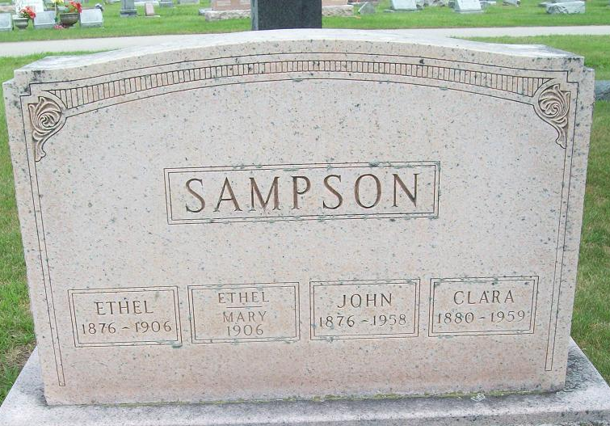
Photo by Alicia Kneuss

Mary Ethel Burkhead was born at Decatur, Ind. Feb. 19, 1876, and died at Fort Wayne, May 30, 1906, age 30 years, 3 months and 11 days. Eight years ago she was married to Mr. John Sampson, to which union were given five children, two boys and three girls, age 7, 5, 3, and the infant twins but a few days old. About the time of her marriage to Mr. Sampson, she saw fit to join herself by repentance and faith to another friend, which friend was her Divine Lord. With Him, we believe she also lived in loving fellowships and service through these years that have come and gone.
At her conversion, which occurred in the U. B. Church of this city, she became a member of said church, which relation was continued until their removal to Fort Wayne, but her closing words to husband and friends strongly indicated that her relation with her Divine friend and Lord was unbroken to the end.
Though her spirit took its flight so soon, in the very summer of life, and at a season when all nature seemed to vie in making life delightful, yet we shall trust she has lived long enough, and well enough, to make possible an eternal life among environments the best that her Divine friend and Lord could provide.
She had the happy faculty of making friends, who, in a very large degree, share with the husband and children, the parents and all relatives, in bearing the great sorrow which has come to them.

Decatur Daily Democrat, Adams County, Indiana
(a weekly newspaper)
Thursday, June 7, 1906

