Clara A. (Showalter) Sampson
June 10, 1880 – November 10, 1959

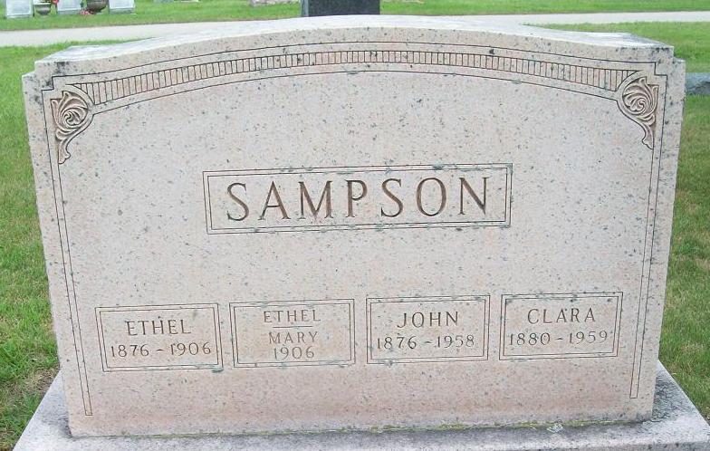
Photo by PLS

Clara A Sampson
in the Indiana, U.S., Death Certificates, 1899-2017
Name Clara A Sampson
[Clara A Showalter]
Gender Female
Race White
Age 79
Marital Status Widowed
Birth Date 10 Jun 1880
Birth Place Van Wert County, Ohio
Death Date 10 Nov 1959
Death Place Fort Wayne, Allen, Indiana, USA
Death Registration Date 1959
Father: Peter Showalter
Mother: Jane Heath
Informant: Clarence Sampson; son; Fort Wayne, Indiana
Burial: November 13, 1959; Maplewood Cemetery; Decatur, Indiana

