Charles T. Sampson
1850 – March 11, 1916

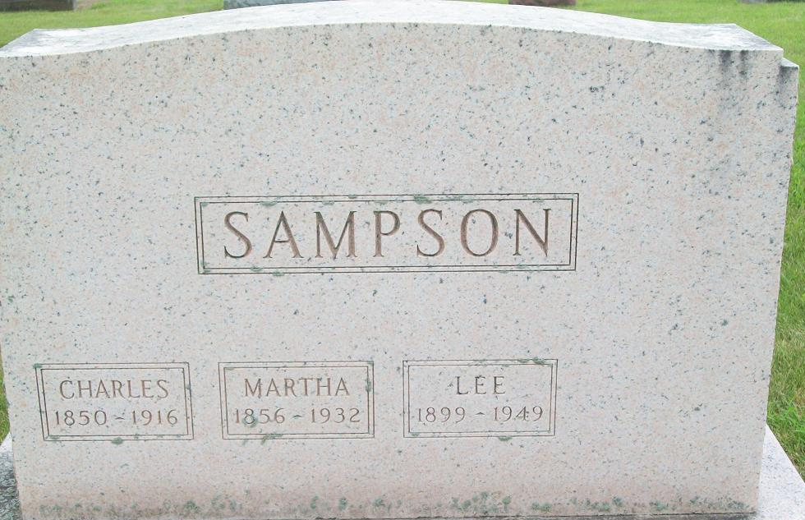
Photo by PLS

A SUDDEN DEATH
Came to Charles Sampson in Wisconsin - Former Decatur Resident
BODY TO ARRIVE
Here Tomorrow - Will Be Taken to Home of Son, Lewis Sampson

(Missing)...this city, received a message today telling of the sudden death of his father, Charles Sampson, at Belluntis, Wisconsin. The death occurred Saturday, but no details have been received. The remains will arrive here Wednesday and will be taken to the home of Lewis Sampson.
The deceased is survived by six children, Mrs. Millie Dickie, Mrs. Susie Huges, and Mrs. Katie Lawhead of Fort Wayne, John Sampson of Grand Rapids, Nelson Sampson, Fort Wayne, and Lewis Sampson of this city.
Mr. Sampson lived here a number of years and will be well remembered by the older citizens of Decatur.
The funeral arrangements have not been completed, awaiting the arrival of members of the family.

Decatur Daily Democrat, Adams County, Indiana
Monday, March 13, 1916
**
BODY ARRIVES
Body of Charles Sampson Arrived From Wisconsin This Morning
TAKEN TO THE HOME
Of Son, Lewis Sampson - Funeral Thursday Afternoon at the Home

The body of Charles Sampson, whose death has occurred in Wisconsin, at the home of a relative, arrived here this morning at 7:01 o'clock over the G. R. & I. and was taken to the home of a son, Lewis Sampson, on South Eighth Street. The funeral will be held Thursday afternoon at 2 o'clock at the residence, the Rev. T. H. Harman of the United Brethren Church officiating. Burial will take place in the Decatur cemetery. The body was accompanied here by the son, John Sampson, of Grand Rapids, Mich. The deceased was sixty-six years old.
Mr. Sampson's death resulted from pneumonia and he had been ill only two days.

Decatur Daily Democrat, Adams County, Indiana
Wednesday, March 15, 1916
**

Charles T Sampson from tree Lindley Family Tree.2
Birth Dec 1849 Ashippun, Dodge, Wisconsin, USA
Marriage 1875 Wisconsin, USA
Residence 1880 Adams, Indiana, USA
Death 11 Mar 1916 Adams, Indiana, USA
Father Charles W Sampson (1822-1862)
Mother Araminta M Hartwell (1824-1862)
Spouse Martha Close (1856-1932)

