Waldo L. Salway
May 8, 1930 – July 12, 2022

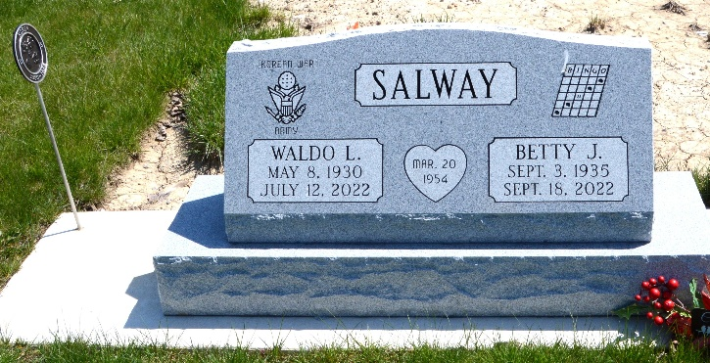
Photo of Barbara Baker Anderson

Waldo L. (Walt) Salway, 92, of Decatur, IN passed away Tuesday, July 12, 2022 at Coventry Meadows in Fort Wayne. Walt was born in Monroeville, IN on May 8, 1930 to the late David and Lelah (Chapman) Salway. On March 20, 1954, he married Betty Brunner.
Walt was an active War Veteran during Korea in the United States Army and retired from International Harvester.
He is survived by his wife, Betty Salway of Coventry Meadows, Fort Wayne; 4 daughters, Barbara (Dave) Perks of Berne, IN, Cheryl (Rick) McCullough of Auburn, IN, Dianna (Jerry) Brooks of Warren, IN and Anita (Steve) Sell of Decatur, IN; son, Greg (Lisa) Salway of Ft. Wayne, IN; 2 brothers, Jim Salway of Waterloo, IN and Noel (Pat) Salway of Decatur, IN; 13 grandchildren and 12 great grandchildren.
He was preceded in death by, 1 granddaughter, Nacole; 11 brothers and sisters, Howard, Harold, Don, Lola, Lila, Louise, Mary, Bud, Johnny, Whitey and Dorothy.
Visitation will be from 5:00 – 7:00 p.m. on Thursday, July 14, 2022 at Haggard-Sefton-Hirschy & Zelt Funeral Home.
A 1:00 p.m. Funeral Service will be held on Friday, July 15, 2022 also at the funeral home with calling 1 hour prior to service from Noon-1:00 p.m. Pastor Troy Drayer officiating. Burial will follow in Decatur Cemetery, with Military Graveside Rites by American Legion Post #43 Color Guard.
Preferred memorials are to American Legion Post #43 Color Guard.

Haggard & Sefton Funeral Home, Adams County, Indiana
July 12, 2022

