Peggy Sue Salway
September 9, 1958 – September 11, 1958

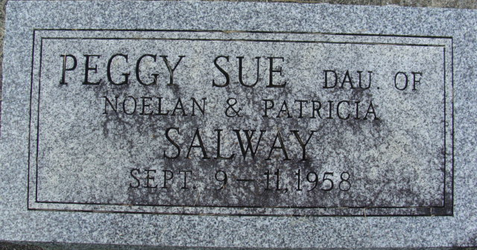
Photo by Alicia Kneuss

Salway
in the Indiana, U.S., Death Certificates, 1899-2017
Name Salway
Gender Female
Race White
Age 2 days
Marital Status Never Married (Single)
Birth Date 9 Sep 1958
Birth Place Indiana
Death Date 11 Sep 1958
Death Place Fort Wayne, Allen, Indiana, USA
Death Registration Date 1958
Father: Noelan Salway
Mother: Patricia Hurst
Informant: Father
Burial: September 13, 1958; Maplewood Cemetery; Decatur, Indiana

