Noelan E. Salway
May 17, 1933 – October 5, 2024

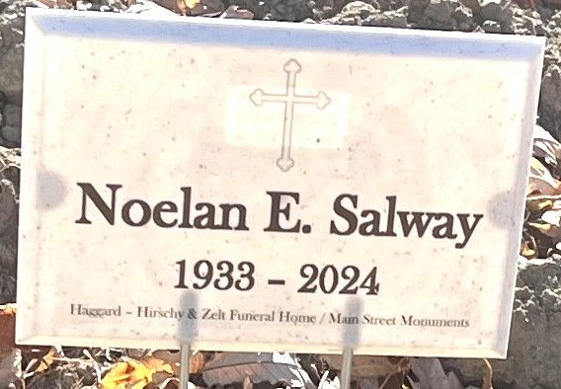
Photo by Deb Curry

Noelan E. Salway, 91, of Monroeville, passed away Saturday, October 5, 2024, at his residence. He was born on May 17, 1933, in Monroeville, Indiana, to the late David and Lela (Chapman) Salway. On June 9, 1956, Noel married Patricia Hurst.
Noel served his Country in the United States Army. He was a devoted member of East Liberty Wesleyan Church where he faithfully served many roles over the years.
He is survived by his wife of 68 years, Patricia Salway of Monroeville; his children, Edward Salway of Fort Wayne, Jeffery (Ramona) Salway of Decatur, Scott Salway of Monroeville, Debra Schneider of Fort Wayne, Justin Salway of Decatur, and Jason “Jake” Salway of Indianapolis. Noel is also survived by a brother, James “Jim” Salway of Fremont, IN; three grandchildren, April Hockemeyer, Jessica & Jordan Schneider; one great grandson, Luke Hockemeyer; a great-great grandson & a great-great granddaughter.
Noel was preceded in death by his daughter, Peggy Salway; twelve siblings, Howard, Harold, Don, Lola, Lila, Louise, Mary, Bud, Johnny, Whitey, Dorothy & Waldo.
Visitation will be from 2:00 - 7:00 p.m. on Wednesday, October 9, 2024, at Haggard-Hirschy & Zelt Funeral Home. A Funeral Service will be held at 11:00 a.m. on Thursday, October 10, 2024, at East Liberty Wesleyan Church, with visitation prior to the service from 10:00 – 11:00 a.m. Pastor Dennis Croy and Pastor Ralph Klinker will be officiating. Burial will take place in the Decatur Cemetery.
Memorials may be given to Riley Children’s Hospital or St. Jude Children’s Hospital.

Haggard & Sefton Funeral Home, Adams County, Indiana
October 6, 2024

