Betty J. (Brunner) Salway
September 3, 1935 – September 18, 2022

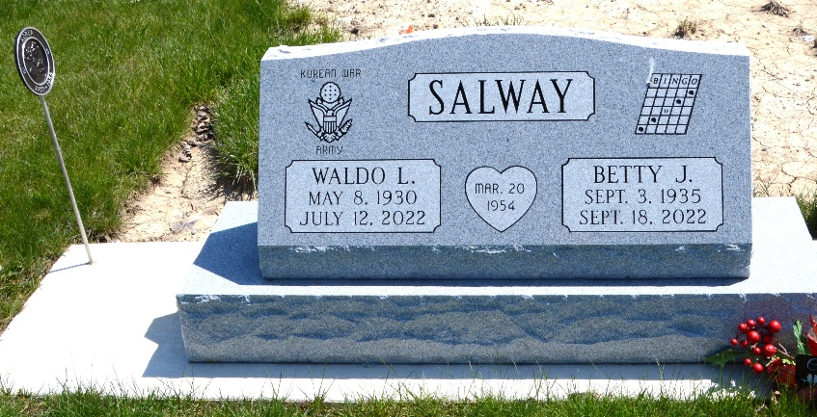
Photo of Deb Curry

Betty J. Salway, 87, of Decatur, passed away on Sunday, September 18, 2022, at Coventry Meadows, in Fort Wayne. She was born on September 3, 1935, in Decatur, the daughter of Harvey and Melvina (Sudduth) Brunner. On March 20, 1954, she married Waldo “Walt” Salway and after 68 years of marriage, he preceded her in death on July 12, 2022.
She was employed by General Electric, after retiring from there, she worked on the Adams County EMS.
Betty is survived by her 4 daughters, Barbara (Dave) Perks of Berne, IN, Cheryl (Rick) McCullough of Auburn, IN, Dianna (Jerry) Brooks of Warren, IN, Anita (Steve) Sell of Decatur, IN; her son, Greg (Lisa) Salway of Fort Wayne, IN; 13 grandchildren; 12 great grandchildren.
She was preceded in death by her brother, John Brunner; her sister, Sally Golliff; 1 granddaughter, Nacole Dellinger.
Visitation will be from 5:00 – 7:00 p.m. on Wednesday, September 21, 2022, at Haggard-Hirschy & Zelt Funeral Home, Decatur, Indiana.
A 10:30 a.m. Funeral Service will be held on Thursday, September 22, 2022, also at the funeral home with calling 1 hour prior to the service from 9:30 – 10:30 a.m. Pastor Troy Drayer will be officiating and burial will follow in Decatur Cemetery.
Memorials may be made to American Legion Post #43 Color Guard.

Haggard & Sefton Funeral Home, Adams County, Indiana
September 19, 2022

