Rose (Schlickman) Sage
June 24, 1890 – June 7, 1937

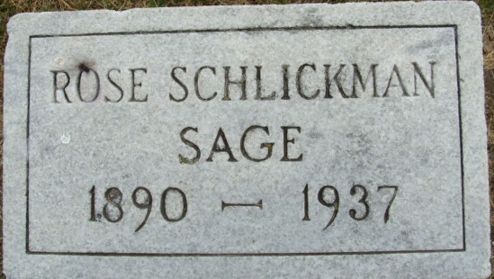
Photo by Alicia Kneuss

Rose Schlickman
in the 1920 United States Federal Census
Name Rose Schlickman
Age 27
Birth Year abt 1893
Birthplace Indiana
Home in 1920 Denver, Denver, Colorado
Street Corona St
Race White
Gender Female
Relation to Head of House Sister
Marital Status Single
Father's Birthplace Germany
Mother's Birthplace Indiana
Able to Speak English Yes
Occupation Fancy Needleworker
Industry Dressmaking Co
Able to read Yes
Able to Write Yes
Household Members (Name) Age Relationship
Erma Schlickman; 35; Head
Rose Schlickman; 27; Sister
Dora Schlickman; 25; Sister
**
Colorado, U.S., County Marriage Records and State Index, 1862-2006
Name Rose Schlickman
Gender Female
Age 27
Birth Date abt 1896
Marriage Date 1 Dec 1923
Marriage Place Colorado Springs, El Paso, Colorado, USA
Spouse Earl E Sage
Film Number 001690130
**

Colorado Statewide Divorce Index, 1900-1939
Name Rose Sage
Spouse's Name Earl E Sage
Marriage Date: 1 December 1923
Event Type Divorce
Event Date: 21 November 1925
Event Place Denver, Colorado, United States
Court Docket Number 66999
**

1930 United States Federal Census
Name Rose Sage
[Rose Dage]
Birth Year abt 1891
Gender Female
Race White
Age in 1930 39
Birthplace Indiana
Marital Status Divorced
Relation to Head of House Sister
Home in 1930 Denver, Denver, Colorado, USA
Street Address Corona Street
Ward of City Election Dist S
Block 4567
House Number 1416
Dwelling Number 64
Family Number 115
Attended School No
Able to Read and Write Yes
Father's Birthplace Germany
Mother's Birthplace Indiana
Occupation Dressmaker
Industry Estatelishmet
Class of Worker Wage or salary worker
Employment Yes
Household Members (Name) Age Relationship
William Lawris; 38; Head
Dora Lawris; 37; Wife
Rose Sage; 39; Sister
**

Rose Schlickmann from tree Helm & Lammert
Birth 24 Jun 1890 Adams, Indiana, USA
Residence 1930 Denver, Denver, Colorado, USA
Death 7 Jun 1937
Father Ernst Jacob Schlickmann (1856-1943)
Mother Elizabeth Marie Lammert (1861-1940)
Spouse Sage

