Homer Allen Ruhl
January 30, 1889 – December 31, 1940

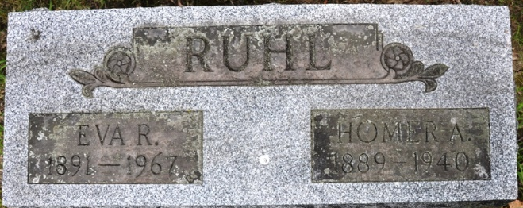
Photo by Deb Curry

RUHL

DECATUR, Jan. 1 – Funeral services for Homer A. Ruhl, prominent Decatur man who died suddenly at Indianapolis Tuesday morning, will be held at the Zwick Funeral Home Friday at 10:30 a.m., Rev. Kenneth Timmons of the First Christian Church officiating. Burial will be in the Decatur Cemetery.

Journal Gazette, Allen County, Indiana
January 2, 1941

**
Indiana, U.S., Death Certificates, 1899-2017

Name Homer Allen Ruhl
Gender Male
Race White
Age 51
Marital Status Married
Birth Date 30 Jan 1889
Birth Place Allens County Indiana
Death Date 31 Dec 1940
Death Place Indianapolis, Marion, Indiana, USA
Death Registration Date 1940
Father: John C Ruhl
Mother: Alice Albaugh
Spouse: Eva Ake
Informant: Mrs. Eva Ruhl; Decatur, Indiana
Burial: January 2, 1941; Decatur Cemetery; Decatur, Indiana

