Melanie Ann (Bowen) Reihman
October 16, 1958 – October 6, 2020

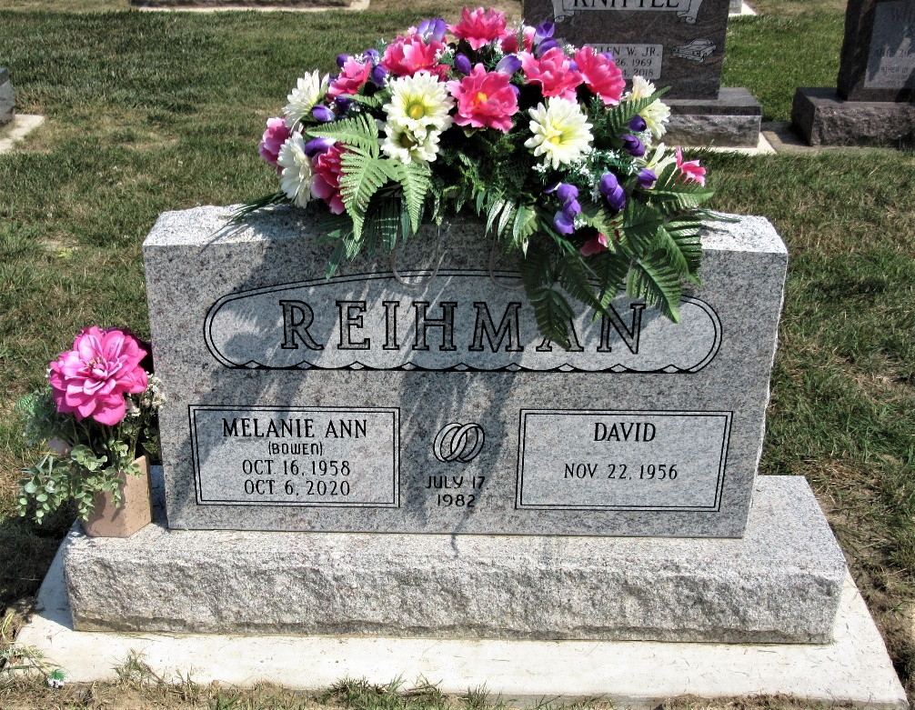
Photo by PLS

Melanie Ann (Bowen) Reihman, 61 of Cincinnati, Ohio passed away October 6, 2020 at Hospice Home of Cincinnati after a two and a half year battle with breast and bone cancer. She was born October 16, 1958 in Decatur to Allen and Ann Bowen. She was married to David Reihman on July 17, 1982 in Decatur.
She was a 1977 graduate of Adams Central High School and graduated from Purdue University in 1982. She taught pre-school at Pleasant Park Preschool for 21 years. She loved teaching the little people. She enjoyed their yearly summer vacation to Hilton Head Island and loved working with her flowers. She had many friends and truly enjoyed life. She was a wonderful daughter and sister, a loving wife, mother and grandmother. Her grandkids were the love of her life.
She is survived by her parents of Decatur; her husband David; two children, Nicholas and Carli; grandchildren, Makenzie and Aidan, all of Cincinnati, Ohio; sister Lisa (Rex) Harris of West Chester, Ohio; and very special friend and cousin Diane (Tim) Zeser of Decatur.
A memorial visitation will be held at Vorhis & Ryan Funeral Home, 11365 Springfield Pile, Springdale, Ohio from 11 a.m. to 2 p.m. on Saturday, October 17 with service to follow. A memorial service will also be held at 11 a.m. at the Decatur Cemetery on Saturday, October 24 with Rev. Ernie Suman officiating.
Memorials may be made to the Adams County Cancer Coalition, 313 W. Jefferson St. #302, Decatur, Indiana 46733.

Berne Witness, Adams County, Indiana
October 14, 2020

