Leander Reffey
July 24, 1870 – June 26, 1952

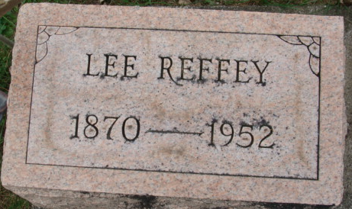
Photo by Alicia Kneuss

Lee Reffey, 81, Dies at Hospital

Decatur, June 27 - Lee Reffey, 81, retired Decatur Casting Company employee and a painter, died at 3:15 a.m. Thursday in the Adams County Memorial Hospital, where he was taken after suffering a stroke Wednesday afternoon at his home here. He was a native and lifelong resident of Adams County.
Surviving is the wife, Pearl; five daughters, Mrs. Adrian Baker, Mrs. Leland Smith and Mrs. Theodore Sovine of Decatur, Mrs. Raymond Brandyberry, Fort Wayne, and Mrs. Harry Merriman, Kankakee, Ill., and six grandchildren.
The body is at the Zwick Funeral Home, where friends may call. Services will be conducted at 2 p.m. Saturday at the funeral home, with the Rev. Samuel Emerick, pastor of the First Methodist Church officiating. Burial will be in the Decatur Cemetery.

Adams County Historical Museum, Indiana
May 1952 – March 1955 Scrapbook
Handwritten date: Friday, June 27, 1952

**
Indiana, U.S., Death Certificates, 1899-2017
Name Leander Reffey
Gender Male; Race White
Age 81
Marital Status Married
Birth Date 24 Jul 1870
Birth Place Indiana
Death Date 26 Jun 1952
Death Place Decatur, Adams, Indiana, USA
Father: David Reffey
Mother: Ann McClain
Informant: Mrs. Pearl Reffey; Decatur, Indiana
Burial: June 28, 1952; Decatur Cemetery; Decatur, Indiana

