Wilbur Gene Rash
April 22, 1923 – January 14, 1992

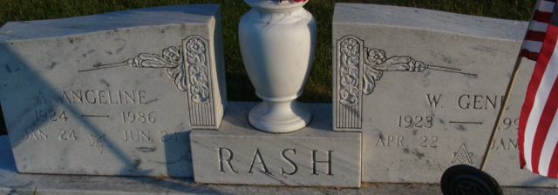
Photo by Alicia Kneuss

Wilbur Gene Rash, 68, of Decatur died yesterday in Adams County Memorial Hospital. He was a retired farmer, also retired in 1973 from the Indiana State Police after 20 years, worked eight years as an inspector for the Indiana State Board of Health, was a veteran of World War II and widower of Angeline, who died in 1986.
Surviving are daughters, Kathy Brecht and Mary Margaret Passwater, both of Decatur, and Carolyn Scherrer-Stoppenhagen of Ossian; a son, Curtis of Decatur; and 10 grandchildren.
Services are 11 a.m. Friday in First Presbyterian Church, Decatur. Calling is 2 to 5:30 and 7 to 9 p.m. tomorrow in Haggard & Armes Funeral Home, Decatur, and 10 to 11 a.m. Friday in the church. A Masonic memorial service is at 8:45 p.m. tomorrow in the funeral home. Burial will be with military honors in Decatur Cemetery.
Preferred memorials are gifts to the American Heart Association.

News-Sentinel, Allen County, Indiana
Wednesday, January 15, 1992

**
FATHER OF OSSIAN RESIDENT, WILBUR GENE RASH, 68, DIES

Wilbur Gene Rash, 68, of Decatur, died at 10:27 a.m. Tuesday at Adams County Memorial Hospital.
He was a retired farmer and also retired from the Indiana State Police in 1973 after 30 years. He worked as an inspector for the Indiana State Board of Health for eight years and was a Navy veteran of World War II.
His wife, Angeline, died in 1986.
Surviving are three daughters, Carolyn Scherrer Stoppenhagen of Ossian, Kathryn Brecht and Mary Margaret Passwater, both of Decatur; a son, Curtis Rash of Decatur and 10 grandchildren.
Friends may call from 2 - 5:30 and 7 to 9 p.m. Thursday at Haggard & Armes Funeral Home, Decatur, where Masonic services will be at 8:45 p.m.
The body will lie in state one hour prior to 11 a.m. funeral services Friday at the First Presbyterian Church in Decatur. Burial will be in Decatur Cemetery with military graveside rites by American Legion Post 43.
Suggested memorials are to the American Heart Association.

Unknown source
Wednesday, January 15, 1992

**
Indiana, U.S., Death Certificates, 1899-2017
Name Wilbur Gene Rash
Gender Male
Race White
Age 68
Marital Status Widowed
Birth Date 22 Apr 1923
Birth Place Fountain City, Indiana
Death Date 14 Jan 1992
Death Place Decatur, Adams, Indiana, USA
Death Registration Date 1992
Father: Curtis T Rash
Mother: Sadie O Petro
Informant: Curtis H. Rash; son; Decatur, Indiana
Burial: January 17, 1992; Decatur Cemetery; Decatur, Indiana

