Elnora Katherine (Ross) Price
June 14, 1924 – August 28, 2008

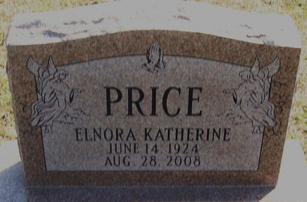
Photo by Alicia Kneuss

Elnora Katherine (Kate) Price, 84, of Decatur passed away on Thursday, August 28, 2008 at Woodcrest Nursing Home. Kate was born June 14, 1924 in Decatur, Indiana to the late Merlin F. Ross & Rozantha (Stauffer).
She is survived by a son Rodney (Renee) Price and a daughter Mrs. William (Shery) Huffman both of Decatur; 4 grandchildren and 5 great grandchildren. Preceding her in death is a brother Merlin Ross, Jr and a great granddaughter Shayla Roz Huffman.
Kate was a member of Zion United Church of Christ in Decatur. She was a homemaker and worked as a Nurse’s Aide for 25 years at Caylor Nickel Clinic in Bluffton.
Funeral services will be held on Tuesday, September 2, 2008 at 2:00 pm at Haggard & Sefton Funeral Home with 1 hour calling prior to services. Rev. Eric Stoops will be officiating and burial is in Decatur Cemetery.

Haggard & Sefton Funeral Home, Adams County, Indiana
August 29, 2008

*****
Indiana, Death Certificates, 1899-2011
Name: Elnora K Price
Maiden Name: Ross
Gender: Female
Race: White
Age: 84
Marital status: Divorced
Birth Date: 14 Jun 1924
Birth Place: Decatur, In
Death Date: 28 Aug 2008
Death Place: Decatur, Adams, Indiana, USA
Father: Merlin F Ross
Mother: Rozantha Stauffer
Informant: Shery Huffman; daughter; Decatur, Indiana
Burial: Decatur Cemetery; Decatur, Indiana

