Yvette Porter
July 1, 1956 – July 1, 1956

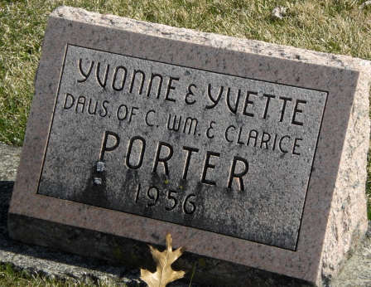
Photo by Alicia Kneuss

Rites Held Today For Porter Twins
Graveside services were held at the Decatur Cemetery this afternoon for Yvette, and Yvonne Porter, twin girls born prematurely to William and Clara Sauer-Porter, 421 Fornax Street. The infants died a few hours after birth Sunday at the Adams County Memorial Hospital.
Surviving in addition to the parents are the grandparents, Mr. and Mrs. Phil Sauer and Mr. and Mrs. Vane Porter. The Rev. O.C. Busse officiated at the service, conducted by the Black Funeral Home.
Decatur Daily Democrat, Adams County, Indiana
Monday, July 2, 1956

