Clarice P. “Kelly” (Sauer) Porter
May 8, 1927 – September 18, 2025

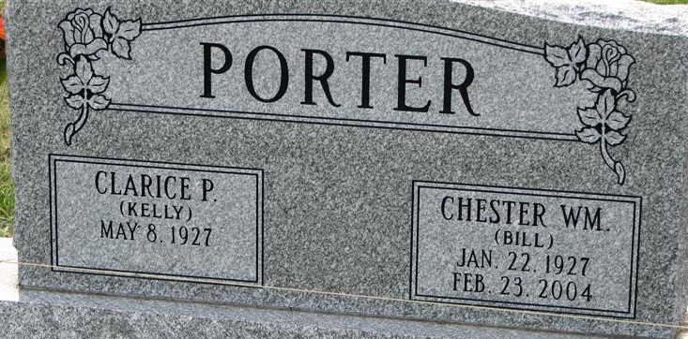
Photo by Alicia Kneuss

Clarice P. "Kelly" Porter, 98, of Decatur, passed away Thursday morning, September 18, 2025, at her residence. She was born in Decatur, IN, on May 8, 1927, the daughter of the late Philip and Mina (Weinman) Sauer. On July 29, 1951, Clarice married Chester William Porter, he preceded her in death on February 23, 2004.
She was a member of Zion Lutheran Church in Decatur, Director of Funeral Dinners and was in the Quilting Club at the church. Kelly participated in the Bowling Leagues at Villa Lanes. She was a member of Moose Lodge & American Legion. Kelly worked for the Telephone Company, Yost Gravel Pit, Bellmont High School Café, CTS in Berne and volunteered with North Adams Community Schools bus system. She also enjoyed playing cards, Bingo, dice, watching sports, crocheting & knitting, and helping children with disabilities.
Kelly is survived by her 2 sons, Dennis (Roxanne) Porter of Columbia City, IN, and Jeff Porter of Hamilton, IN; a daughter, Rita Biedermann of Decatur, IN; a brother, Ralph (Marilyn) Sauer of Decatur, IN; 2 grandchildren, Alyson (Jeremy) Rauch & David (Amber) Porter; 7 great grandchildren, Keegan, Eli, Jaelyn, Allona, Savannah, Quentin & Braxton.
She was preceded in death by her husband of 52 years, Bill Porter; twin daughters, Yonnevon & Yette; a son-in-law, Scott Biedermann; a brother, Harold Sauer; 3 sisters, Florence Engle, Vera Hammond & Wilma Sauer.
Visitation will be from 4:00 – 7:00 p.m. on Monday, September 22, 2025, at Haggard-Hirschy & Zelt Funeral Home. A Funeral Service will be held at 10:30 a.m. on Tuesday, September 23, 2025, at Zion Lutheran Church, with visitation prior to the service from 9:30 -10:30 a.m. Rev. Zach Oedewaldt will be officiating and burial will follow in Decatur Cemetery. Memorials may be made to Zion Lutheran Church or Heartland Hospice. Arrangements are entrusted to Haggard-Hirschy & Zelt Funeral Home.

WFFT-TV 55 News, Allen County, Indiana
Sep. 18, 2025

