Mary E. Patterson
December 17, 1837 – August 21, 1849

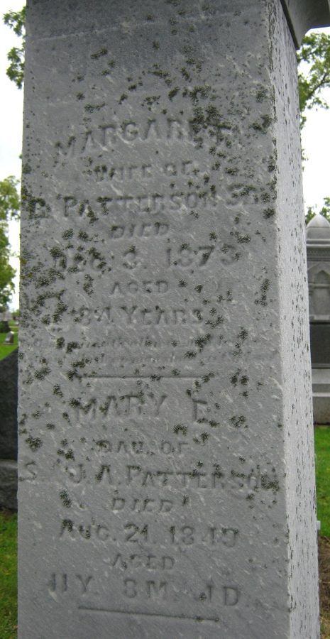
Photo by S Riley

Patterson, Mary E., dau of Margaret, d. August 21, 1849, age 11 yrs. 8 mo. 4 da.

Adams Public Library System, Decatur, Indiana
Maplewood Cemetery reading

Inscription: d/o JA & Samuel

