Nancy J. (Baumgartner) Painter
November 12, 1937 – February 3, 2024

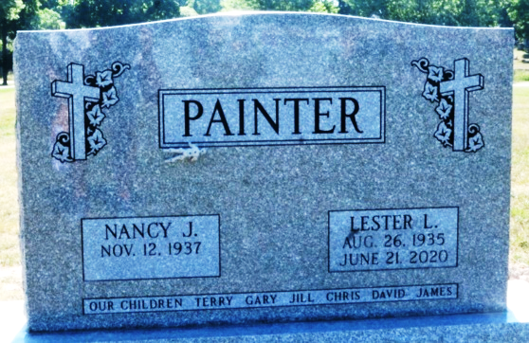
Photo by Deb Curry

Nancy J. Painter, 86, of Hoagland, Indiana passed away Saturday, February 3, 2024, at Cedarhurst Senior Living, in Fort Wayne, Indiana.
She was born on November 12, 1937, in Decatur, Indiana to the late Melvin Baumgartner and Myrtle Marie (Evans) Baumgartner. Nancy was united in marriage to Lester L. Painter on September 18, 1954, in Decatur, and he preceded in death on June 21, 2020.
Nancy was a graduate of Monmouth High School. Most recently, Nancy was a member of Emanuel Lutheran Church in New Haven, Indiana, and she was also member of Hope Lutheran Church in Bradenton, Florida during the years she lived in Florida.
Nancy served as a bus driver for East Allen County Schools for 24 years.
Mom loved family, driving bus, riding bikes, and playing cards. She loved her husband, Lester and missed him dearly since his death in 2020. She was known for her fabulous cooking, making holidays very special, and her king’s cookies. Nancy and Lester loved camping and traveling. Her grandchildren loved making noodles with her and much more…
Nancy is survived by her daughter, Terry Lynne (David) Williams of San Antonio, Texas; son, L. Gary Painter, DDS of Estero, Florida; son, Chris Eric Painter of Hoagland, Indiana; son, David Dean (Julie) Painter, DDS of Auburn, Indiana; son, James Todd (Rachel) Painter of Berne, Indiana; sister, Carol Seitz of Decatur, Indiana; brother, Larry Baumgartner of Arizona; 12 grandchildren and three step-grandchildren.
In addition to her husband and parents, Nancy was preceded in death by her daughter, Jill Kristen Painter; brother, Danny Baumgartner; and daughter-in-law, Judy Painter.
A funeral service will be held at 1:00 p.m. Friday, February 9, 2024, at the Zwick & Jahn Funeral Home in Decatur with Pastor Scott Zeckser officiating. Burial will follow at Decatur Cemetery.
Friends and family will be received from 11:00 a.m.-1:00 p.m. prior to the service on Friday at the funeral home.
Preferred memorials are to Emmanuel Lutheran Church in New Haven, Indiana.

Zwick & Jahn Funeral Home, Adams County, Indiana
February 6, 2024

