Harold C. Painter
July 17, 1953 – August 24, 2021

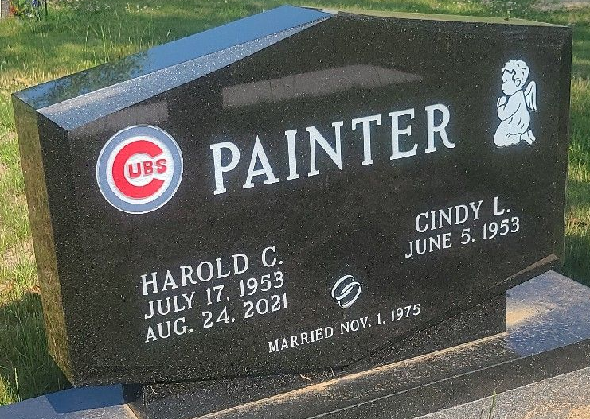
Photo by Jenna Langston

Harold C. Painter, 68, of Decatur, Indiana passed away Tuesday afternoon, August 24, 2021, at Adams Memorial Hospital. He was born on July 17, 1953 in Decatur, Indiana to Clarence O. and Ada I. (Steffen) Painter. Harold was united in marriage to Cindy Murray on November 1, 1975 at Zion United Church of Christ in Decatur.
He was a member of the Masonic Lodge #571 of Decatur. Harold retired from North Adams Community School with 37 years of service.
He was an avid fan of the Chicago Cubs and a Chicago Bears fan. He enjoyed reading and watching his grandson bowl.
He is survived by his wife, Cindy Painter of Decatur, Indiana; daughter, Jennifer (Ben) Kaiser of Decatur, Indiana; two sisters, Wanda (Jerry) Selking of Decatur, Indiana and Shirley Gause of LaFayette, Indiana; grandson, Xavier Kaiser of Decatur, Indiana; mother-in-law, Phyllis Jean Murray of Decatur, Indiana; sister-in-law, Deedra Pickford of Urbana, Ohio; brother-in-law, Bill Murray of Decatur, Indiana; and several nieces and nephews.
He was preceded in death by his parents; his daughter, Sarah, in infancy; a brother, Steve Pickford; and sister-in-law, Judy Murray.
A Masonic Service will be held at 3:00 p.m. Saturday, August 28, 2021, immediately followed by a Celebration of Harold’s Life at Zwick & Jahn Funeral Home in Decatur with Molly Farthing officiating. Burial will follow at Decatur Cemetery.
Family and friends will be received from 12 noon to 3 p.m. Saturday prior to the services at the funeral home.
Preferred memorials are to P.A.W.S of Adams County or Lennoxs Legacy Rescue.

Zwick & Jahn Funeral Home, Adams County, Indiana
August 25, 2021

