Cindy L. (Murray) Painter
June 5, 1953 - September 20, 2023

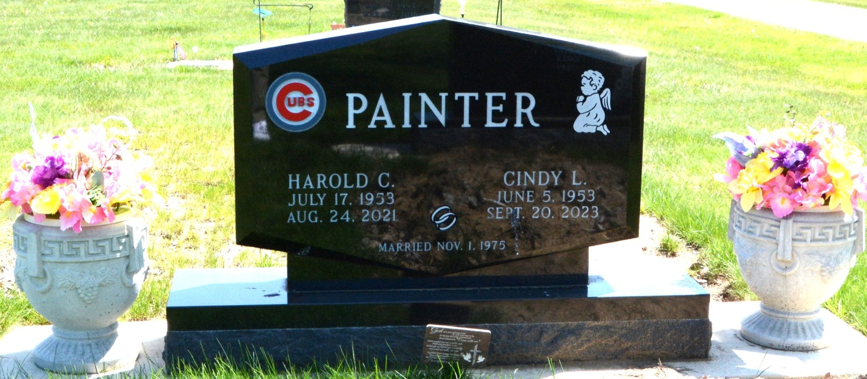
Photo by Deb Curry

Cindy L. Painter, 70, of Decatur, Indiana passed away Wednesday, September 20, 2023, at Adams Memorial Hospital. She was born on June 5, 1953, Decatur, Indiana to the late William and Phyllis Jean (Elzey) Murray. She was united in marriage to Harold C. Painter on November 1, 1975, at Zion United Church of Christ in Decatur. He preceded her in death on August 24, 2021.
Cindy was employed at North Adams Community Schools for many years. She was well known for running the concession stand at Bellmont for many years and baking cookies. Cindy loved spending time with her family and friends and going out to eat.
She is survived by her daughter, Jennifer (Ben) Kaiser of Decatur, Indiana; grandson, Xavier Kaiser of Decatur, Indiana; sister, Deedra Pickford of Urbana, Ohio; sister-in-law, Wanda (Jerry) Selking of Decatur, Indiana; sister-in-law, Shirley Gause of LaFayette, Indiana; several nieces and nephews.
Cindy was preceded in death by her daughter, Sarah Painter; brother, Bill (Judy) Murray; father-in-law, Clarence Painter; and brother-in-law, Steve Pickford.
A funeral service will be held at 2:00 p.m. Tuesday, September 26, 2023, at the Zwick & Jahn Funeral Home in Decatur, Indiana with Life Celebrant Molly Farthing officiating. Burial will follow at Decatur Cemetery. Friends and family will be received from 11:00 a.m. to 2:00 p.m. Tuesday, September 26, 2023, at the Zwick & Jahn Funeral Home in Decatur, Indiana.
In lieu of floral gifts, donations can be made to P.A.W.S of Adams County or Lennoxs Legacy Rescue.

Zwick & Jahn Funeral Home, Adams County, Indiana
September 21, 2023

