Laura (Busenbark) Osborn-Dykeman
January 11, 1869 – January 13, 1958

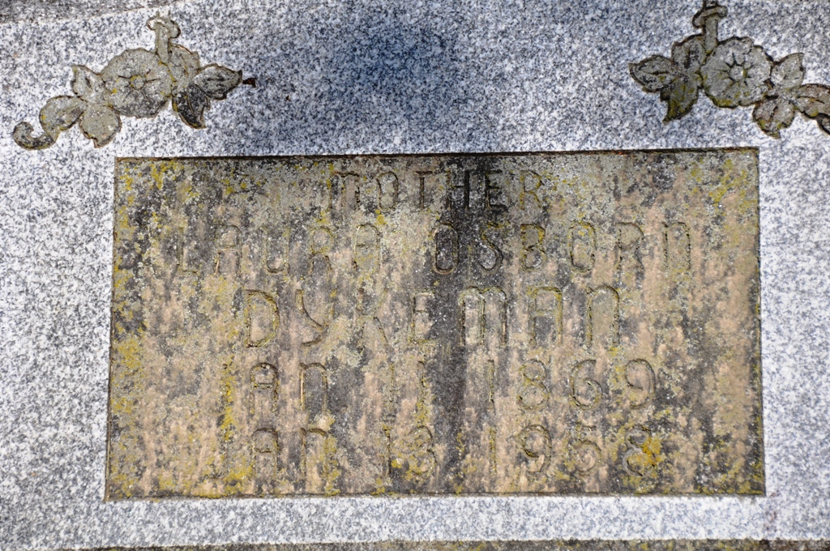
Photo by Deb Curry

Mrs. Laura Dykeman Dies Last Evening
Funeral Services Thursday Morning

Mrs. Laura Dykeman, 89, of Decatur Route 5, four miles northeast of Decatur, died at 6:10 o’clock Monday evening at the Adams County Memorial Hospital, where she had been a patient since Oct. 19.
She was born in Grant County, O., Jan. 11, 1869, a daughter of Mr. and Mrs. John Busenbark. She had lived on the same farm in Union Township since 1903.
Surviving are two sons, C. Dale Osborn of Fort Wayne, and T. Wayne Osborn of Chicago, and the one granddaughter, Catherine Osborn of Fort Wayne. One son and one sister preceded her in death.
Funeral services will be conducted at 10 a.m. Thursday at the Zwick Funeral Home, the Rev. Lawrence T. Norris, officiating. Burial will be in the Decatur Cemetery. Friends may call at the funeral home after 7 o’clock this evening until time of services.

Adams County, Indiana Historical Museum
Jan1958-Dec1960, Image 4
Handwritten-Tues. July 14, 1958

**
2005 Adams County (IN) Death Index
Name: Dykeman, Laura Mrs.
Maiden name: Busenbark
Born: January 11, 1869
Residence: Union Twp, Adams, IN
Death date: January 13, 1958
Death place: Decatur, Adams, IN
Burial: Maplewood/Decatur

**
Indiana, Death Certificates, 1899-2011

Name: Mrs. Laura Dykeman [Mrs. Laura Busenberk]
Gender: Female; Race: White; Age: 89
Marital status: Widowed
Birth Date: 11 Jan 1869; Birth Place: Grant Co. Ohio
Death Date: 13 Jan 1958; Death Place: Decatur, Adams, Indiana, USA
Father: John Busenberk
Mother: unknown
Informant: C Dale Osborn, son, Fort Wayne
Burial: 1-16-1958 Decatur Cemetery

