Claudine M. (Gallogly or Ray) Noll
June 22, 1914 – April 13, 2001

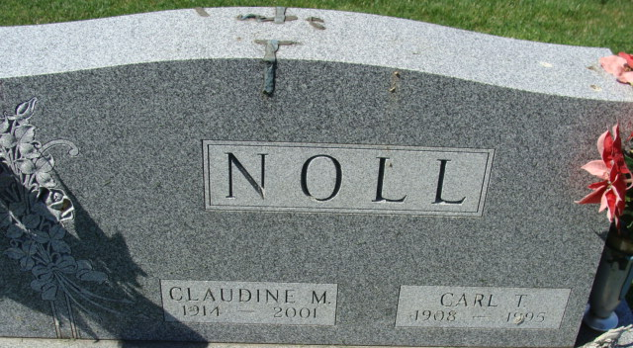
Photo by Alicia Kneuss

Claudine M. Noll, 86, died Friday at home. Born in Adams County, she was a homemaker and formerly worked at Sprague Furniture in Decatur. Her husband, Carl T., died in 1995.
Surviving are a daughter, Karen S. Myers of Portland; two stepsons, Franklin Tom Noll and Robert E. Noll, both of rural Decatur; two brothers, Lawrence Gallogly of rural Decatur and Stanley Gallogly of Decatur; eight grandchildren; 12 great-grandchildren; and a great-great-grandchild.
Services at 11 a.m. Tuesday at Zwick Jahn Funeral Home, Decatur. Calling from 3 to 8 p.m. Monday. Burial in Decatur Cemetery.
Memorials to St. Mark's United Methodist Church or Adams County Heart Club.

Journal Gazette, Allen County, Indiana
April 15, 2001

**
Claudine M. Noll, 86, of Decatur, a member of St. Mark's United Methodist Church, died Friday, April 13, 2001, at home. The Adams County native had been a homemaker and an employee of Sprague Furniture Store in Decatur.
Surviving are her daughter, Karen S. Myers of Portland; stepsons Franklin Tom and Robert E., both of Decatur; brothers Lawrence Gallogly and Stanley Gallogly, both of Decatur; eight grandchildren; 12 great-grandchildren; and one great-great-grandchild. She was preceded in death by her husband, Carl T.; a brother; and a sister.
Services are 11 a.m. Tuesday at Zwick & Jahn Funeral Home, Decatur, with calling from 3 to 8 p.m. today. Burial will be at Decatur Cemetery.
Memorials are to the church or Adams County Heart Club.
News-Sentinel, Allen County, Indiana
April 16, 2001

**
Indiana, U.S., Death Certificates, 1899-2011
Name: Claudine M Noll [Claudine M Gallogly]
Gender: Female; Race: White
Age: 86
Marital status: Widowed
Birth Date: 22 Jun 1914
Birth Place: Adams County Indiana
Death Date: 13 Apr 2001
Death Place: Decatur, Adams, Indiana, USA
Death Registration Date: 2001
Father: Lawrence D Gallogly
Mother: Hazel L Smitley
Informant: Karen S. Myers; daughter; Portland, Indiana
Burial: April 17, 2001; Decatur Cemetery; Decatur, Indiana

**
Indiana, U.S., Birth Certificates, 1907-1944
Name Claudine Marie Ray
Gender Female
Birth Date 22 Jun 1914
Birth Place Decatur, Adams, Indiana, USA
Father: Forest Ray; age 21
Mother: Hazel Smitley; age 19; 1st child
Certificate Number 210; Roll number 40474_357326
Volume Range 721 - 727

