David Calvin Myers
April 5, 1939 - August 28, 2023

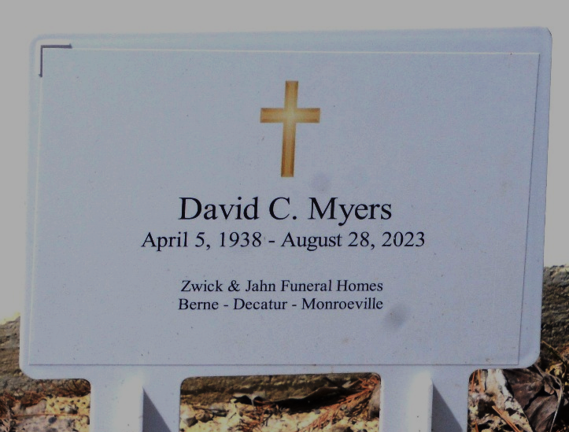
Photo by Deb Curry

David Calvin Myers, 84, of Ohio City, Ohio, passed away peacefully on Monday, August 28, 2023, at VanCrest of Van Wert. He was born on April 5, 1939, in Pleasant Mills, Indiana, to the late Adrian and Bessie (Burkhart) Myers. He was a graduate of Wren High School in 1957.
Dave met the love of his life, Caroline Ann Myers, while he was working as a painter and was assigned a job at the insurance agency where she was working. They were married on June 13, 1964, in the Union United Methodist Church in Willshire, Ohio.
He was a member of the Willshire Union United Methodist Church where he taught Sunday school and was a trustee at the church. More than anything, Dave was a man of God. He loved the Lord, and that was reflected in everything he did. His family takes heart knowing that he now walks with Jesus.
Dave moved from his childhood home and built his family’s home, with his own two hands, right next door, which is where he remained the rest of his life. This was also the place where he loved to be most. There wasn’t anything he couldn’t make or fix. He could often be found in his garage tinkering and creating. Dave was a hard-working man and wasn’t often found sitting idle. He worked at Phelps Dodge, Borden’s Cheese in Van Wert, and eventually retired from Aeroquip in Van Wert as a machinist. He was also a lifelong farmer.
Even more so, he was a family man. Dave and Caroline had four children, Trace, Deborah, Dan, and Becky. He instilled that work ethic and drive in each of his children, and he was so proud of how each one of them turned out and the families they created. Dave was a wonderful husband, father, grandfather, and great-grandfather.
It could also be argued that his tractor was one of his children. He loved his toys: the tractor, gator, and four wheeler. He also loved listening to music (particularly Johnny Cash), visits from his siblings and church family, gardening, bird watching, wood working, farming, and saving money! He had a great sense of humor and loved joking with and pranking his family members. His smile was infectious. He was also stubborn and bullheaded, and he continued to hang onto life, long after his Parkinson’s diagnosis. He wouldn’t let anything stop him from doing what he loved.
Dave is survived by his wife of 59 years, Caroline Ann Myers, of Ohio City, Ohio; son, Tracey (Angie) Myers of Centerburg, Ohio; daughter, Deb (Danelle) McCoy of Ohio City, Ohio; Dan (Tina) Myers of Ohio City, Ohio; and daughter, Becky (Brad) Heth of Ohio City, Ohio; brother, Keith Myers of Ohio City, Ohio; sister, Judy (John) Tumbleson of Wren, Ohio, 11 grandchildren- Curtis (Alyssa) Myers, Nick (Caroline) Myers, Lindsay (Nick) Girod, Natalie (Evan) Vining, David (Becca) Myers, James Myers, Brian Myers, Jake Heth, Andy Heth, Emily Heth, and Alexis Heth; as well as nine great-grandchildren.
He was preceded in death by his parents, Adrian and Bessie Myers; two brothers, Alva and John Myers; and three sisters, Edna Ridenour, Georgia McMillion, and Minnie Andrews.
A funeral service will be held at 11:00 a.m. Saturday, September 2, 2023, at the Zwick & Jahn Funeral Home – Decatur with Pastor Bud Larimore officiating. Burial will follow in the Decatur Cemetery. Family and friends will be received from 4-7 p.m. Friday, September 1, 2023, at the Zwick & Jahn Funeral Home in Decatur, and one hour prior to the service on Saturday at the funeral home.
Preferred memorials can be given to Willshire Union United Methodist Church.

Zwick & Jahn Funeral Home, Adams County, Indiana
August 29, 2023

