Alva Jane (Mowrey) Myers
October 12, 1847 – January 7, 1922

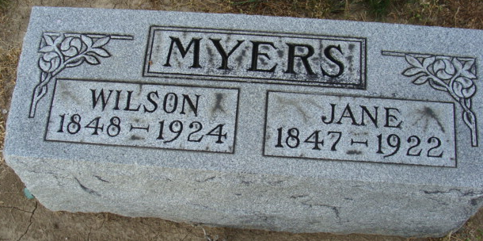
Photo by Alicia Kneuss

MRS. MYERS DIES
Mrs. Alva Jane Myers of Root Township died at her home Saturday night after a long illness from Bright’s disease and a strangled hernia.
She was born in Ohio, October 12, 1847, a daughter of Mr. and Mrs. William Mowrey but had lived here for many years.
She is survived by the husband, Nelson [sic] Myers, and several children and grandchildren.
Funeral services will be held Tuesday afternoon at 1:30 from the home, the Rev. Payne of Craigville officiating. Burial will be at the Decatur Cemetery.
Decatur Daily Democrat, Adams County, Indiana
Monday, January 9, 1922

**
THE MYERS FUNERAL
The funeral of Mrs. Wilson Myers was held at the home in Root Township Tuesday afternoon at 1:30. Mrs. Myers died at her home on Saturday evening at 6:30, after an illness of nineteen weeks from Brights disease and a strangulated hernia. She was born in Wayne County, Ohio, in the year 1847. At her death she was seventy-four years, two months and twenty-one days old. She was the daughter of Mr. and Mrs. William Mowery.
Mrs. Myers had lived in Adams County since she came from Ohio.
She is survived by the husband, Wilson Myers and one son, Sloan Myers, and seven grandchildren and one great-grandchild; also, one sister and brother. Rev. Payne of Craigville officiated at the funeral service. Burial was made in the Decatur Cemetery.
Decatur Daily Democrat, Adams County, Indiana
Wednesday, January 11, 1922

**
Indiana, Death Certificates, 1899-2017

Name: Alva Jane Myers
[Alva Jane Mourrey]
Gender: Female
Race: White
Age: 74y 2m 25d
Marital status: Married
Birth Date: 12 Oct 1847
Birth Place: Ohio City
Death Date: 7 Jan 1922
Death Place: Rooh, Adams, Indiana, USA
Death Registration Date: 1922
Father: William Mowrey
Spouse: unknown
Informant: Sloan Myers
Burial: Decatur Cemetery; Jan 10, 1922

