Sidney Lou (Beery) Moses
August 4, 1943 – December 22, 2023

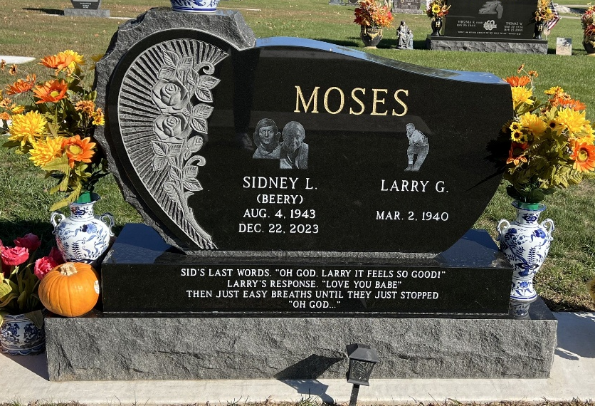
Photo by Deb Curry

Sidney Lou Moses, 80, of Fort Wayne, Indiana, passed away on Friday, December 22, 2023, at Parkview Regional Medical Center.
She was born on August 4, 1943, in Decatur, Indiana to the late Lewis Beery and the late Maxine (Smitley) Beery. Sidney was united in marriage to Larry Moses on March 12, 1960, at First Presbyterian Church in Fort Wayne, Indiana.
Sidney graduated from Decatur High School. She was a homemaker whose first priority was her family. She loved to bowl and was an avid golfer. She won the Club Championship at Cherry Hill Golf Club. Sidney loved to shop, enjoyed collectibles, and growing flowers. She dearly loved all of her Persian cats, which were a constant part of her life throughout the years. When Sidney was younger, she loved to ride horses.
Survivors include her husband, Larry Moses of Fort Wayne, Indiana; son, David (Michele) Moses of Kalamazoo, Michigan; son, Scot (Peggy) Moses of Decatur, Indiana; daughter, Libby (Kelly Conner) Moses of Fort Wright, Kentucky; four grandchildren, Matthew Moses, Michaela Durham, Amanda Culham, and Katlyn Burnfield; and ten great-grandchildren, Maya Moses, Ruby Moses, Benjamin Moses, Brodie Moses, Elysian Durham, Lenley Durham, Austin Culham, Parker Culham, Peyton Culham, and Eli Culham.
Sidney was preceded in death by her brother, Mike Beery; and her grandson, Marcus Moses.
A funeral service will be held at 11:30 a.m. on Thursday, December 28, 2023 at Zwick and Jahn Funeral Home, Decatur, with Life Celebrant Dave McIntire officiating. Burial will follow in Decatur Cemetery. Family and friends will be received from 3 to 6 p.m. on Wednesday, December 27, 2023, and one hour prior to the service on Thursday at Zwick and Jahn Funeral Home, Decatur.
Preferred memorials can be given to A.C.C.F. Angel Fund.

Zwick & Jahn Funeral Home, Adams County, Indiana
December 23, 2023

