Ruth Ann (Girod) Moser
October 17, 1938 – December 24, 2025

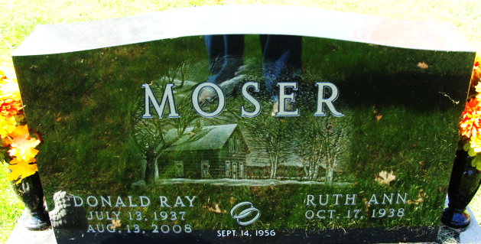
Photo by Alicia Kneuss
Ruth Ann Moser, 87, of Decatur, Indiana passed away on Christmas Eve, December 24, 2025 at Adams Memorial Hospital. Ruth Ann, the daughter of the late Richard C. and Mary E. (French) Girod, was born in Decatur on October 17, 1938. On September 14, 1956, Ruth Ann married Donald R. Moser. He preceded her in death on August 13, 2008.
Ruth Ann was a member of Zion United Church of Christ and their choir, which she loved singing in. Ruth Ann was a 1956 graduate of Decatur High School, where she was instrumental in keeping her class together and organizing many activities.
She worked for many years as a Lunch Lady for North Adams Community Schools before retiring; and recently volunteered in the gift shop at Adams Memorial Hospital and retired from there. She was also a Hostess at Richards Restaurant in her early years. Ruth Ann was a member of the Happy Homemakers Club and she was presently the secretary of her homeowner’s association.
Ruth Ann is survived by her son, Steven R. (Terrie) Moser of Decatur; daughter, Patricia D. (Michael) Sauer of Decatur; son, David R. Moser of Oakland Park, FL; daughter, Tina L. (Jimmy) Kelley of Lynn Haven, FL; 9 grandchildren and 12 great grandchildren. She was preceded in death by a grandson, Joshua Moser, a granddaughter, Jean Nichole; a brother, Richard Girod and 2 sisters, Patricia Walchle and Diana Agler.
Visitation will be on Monday, December 29, 2025 from 3:00 – 7:00 p.m. at Haggard-Hirschy & Zelt Funeral Home. Funeral Services will be held at 1:00 p.m., Tuesday, December 30, 2025 at Zion United Church of Christ with Rev. Allen Kahler officiating. Calling will be prior to services from Noon-1:00 p.m. Burial will follow in Decatur Cemetery.
Preferred memorials are to Zion United Church of Christ.

Haggard & Sefton Funeral Home, Adams County, Indiana
December 26, 2025

