Lynn Carl Moser
November 4, 1959 — January 26, 2017

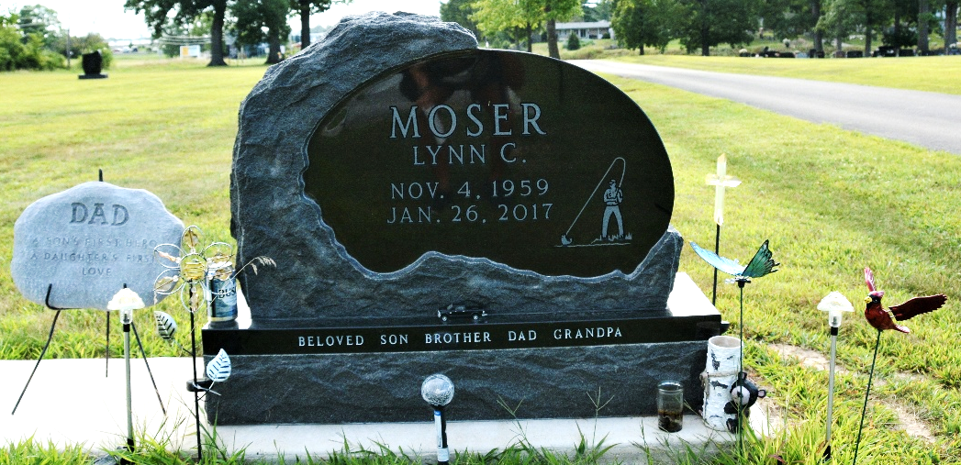
Photo by Deb Curry

Lynn Carl "Moe" Moser, 57 years old of Decatur, IN, passed away on Thursday, January 26, 2017 at his residence. He was born on November 4, 1959 in Adams County the son of the late L. Gene Moser and Florence (Bienz) Moser.
Lynn was a former member of Zion Lutheran Church, Decatur. He was a proud father and grandfather and enjoyed fishing, hunting, nature, and any outdoor activity. He took great pride in his property and how he maintained it. In recent years, he became quite the chainsaw enthusiast. He loved all things MOPAR.
Lynn was employed at Webb Industries in Fort Wayne as a maintenance technician. He was also employed as a senior maintenance technician at Manville in Bluffton until they closed.
Surviving are his daughter, Sasha (Josh) Werst of Decatur, IN; son, Zachary (Ambi) Moser of Decatur, IN; son, Matthew (Tabitha) Moser of Great Lakes, IL; son, Cory Moser of Markle, IN; mother, Florence Moser of Decatur, IN; brother, Duane (Connie) Moser of Decatur, IN; sister, Janet (Jack) Moser of Los Angeles, CA; brother, Gary (Ruymi) Moser of Great Mills, MD; sister, Sandy (Dick) Steury of Decatur, IN; brother, Doug Moser of Huntertown, IN; 8.5 grandchildren: Anthony Bertsch, Skyla Werst, Hailey Bertsch, Grant Bertsch, Mason Moser, Konner Moser, Emilee Werst, Lillian Moser, and Baby Moser due in July.
Funeral services will be held at 10:30 a.m. Thursday, February 2, 2017 at Zwick & Jahn Funeral Home in Decatur with Rev. James Voorman officiating. Interment will follow in the Decatur Cemetery. Friends will be received from 2 to 4 and 5 to 8 p.m., Wednesday, February 1, 2017 at Zwick & Jahn Funeral Home in Decatur.
Preferred memorials are to the family.

Zwick and Jahn Funeral Home, Adams County, Indiana
January 31, 2017

